EXPERIMENT 4.2

🎯 Aim
To design and implement a Student Management System using MongoDB as the database and MVC (Model–View–Controller) architecture to efficiently manage student records such as adding, updating, deleting, and viewing student information.

📖 Theory

1. Student Management System (SMS)
A Student Management System is software that maintains student data such as name, roll number, course, grades, and contact information. It helps in:
- Maintaining records efficiently.
- Performing CRUD (Create, Read, Update, Delete) operations.
- Ensuring centralized access and easy retrieval of data.

2. MongoDB
- A NoSQL document-based database.
- Stores data in BSON (Binary JSON) format.
- Flexible schema: No need for predefined table structures.
- Suitable for applications needing scalability and performance.

3. MVC Architecture
- Model → Manages data and business logic.
- View → Handles the presentation (UI).
- Controller → Acts as a bridge between Model and View, processes user input.
In this project:
- Model → Defines the student schema in MongoDB.
- View → Provides frontend interface (HTML/EJS).
- Controller → Handles routes and operations (CRUD) with the model.

💻 Code (Sample Implementation)
We’ll use Node.js + Express + MongoDB for MVC implementation.

Project Structure
student-management/
│-- app.js
│-- models/
│ └── student.js
│-- controllers/
│ └── studentController.js
│-- routes/
│ └── studentRoutes.js
│-- views/
│ ├── index.ejs
│ ├── addStudent.ejs
│ ├── editStudent.ejs

1. app.js (Entry point)
const express = require("express");
const mongoose = require("mongoose");
const bodyParser = require("body-parser");
const studentRoutes = require("./routes/studentRoutes");

const app = express();

// Middleware
app.use(bodyParser.urlencoded({ extended: true }));
app.set("view engine", "ejs");

// MongoDB connection
mongoose.connect("mongodb://127.0.0.1:27017/studentDB", {
useNewUrlParser: true,
useUnifiedTopology: true,
})
.then(() => console.log("MongoDB Connected ✅"))
.catch(err => console.log(err));

// Routes
app.use("/", studentRoutes);

// Server
app.listen(3000, () => console.log("Server running on http://localhost:3000"));

2. Model (models/student.js)
const mongoose = require("mongoose");

const studentSchema = new mongoose.Schema({
name: String,
rollNo: Number,
course: String,
email: String
});

module.exports = mongoose.model("Student", studentSchema);

3. Controller (controllers/studentController.js)
const Student = require("../models/student");

// Display all students
exports.getStudents = async (req, res) => {
const students = await Student.find();
res.render("index", { students });
};

// Add new student
exports.addStudentForm = (req, res) => {
res.render("addStudent");
};

exports.addStudent = async (req, res) => {
const { name, rollNo, course, email } = req.body;
const newStudent = new Student({ name, rollNo, course, email });
await newStudent.save();
res.redirect("/");
};

// Edit student
exports.editStudentForm = async (req, res) => {
const student = await Student.findById(req.params.id);
res.render("editStudent", { student });
};

exports.updateStudent = async (req, res) => {
await Student.findByIdAndUpdate(req.params.id, req.body);
res.redirect("/");
};

// Delete student
exports.deleteStudent = async (req, res) => {
await Student.findByIdAndDelete(req.params.id);
res.redirect("/");
};

4. Routes (routes/studentRoutes.js)
const express = require("express");
const router = express.Router();
const studentController = require("../controllers/studentController");

// Routes
router.get("/", studentController.getStudents);
router.get("/add", studentController.addStudentForm);
router.post("/add", studentController.addStudent);
router.get("/edit/:id", studentController.editStudentForm);
router.post("/edit/:id", studentController.updateStudent);
router.get("/delete/:id", studentController.deleteStudent);

module.exports = router;

5. Views (EJS Templates)

index.ejs
<!DOCTYPE html>
<html>
<head>
<title>Student Management</title>
</head>
<body>
<h1>Student Records</h1>
<a href="/add">➕ Add Student</a>
<ul>
<% students.forEach(student => { %>
<li>
<%= student.name %> - <%= student.course %>
| <a href="/edit/<%= student._id %>">✏️ Edit</a>
| <a href="/delete/<%= student._id %>">❌ Delete</a>
</li>
<% }) %>
</ul>
</body>
</html>

addStudent.ejs
<h2>Add Student</h2>
<form action="/add" method="POST">
<input type="text" name="name" placeholder="Name" required><br>
<input type="number" name="rollNo" placeholder="Roll No" required><br>
<input type="text" name="course" placeholder="Course" required><br>
<input type="email" name="email" placeholder="Email" required><br>
<button type="submit">Add</button>
</form>

editStudent.ejs
<h2>Edit Student</h2>
<form action="/edit/<%= student._id %>" method="POST">
<input type="text" name="name" value="<%= student.name %>" required><br>
<input type="number" name="rollNo" value="<%= student.rollNo %>" required><br>
<input type="text" name="course" value="<%= student.course %>" required><br>
<input type="email" name="email" value="<%= student.email %>" required><br>
<button type="submit">Update</button>
</form>

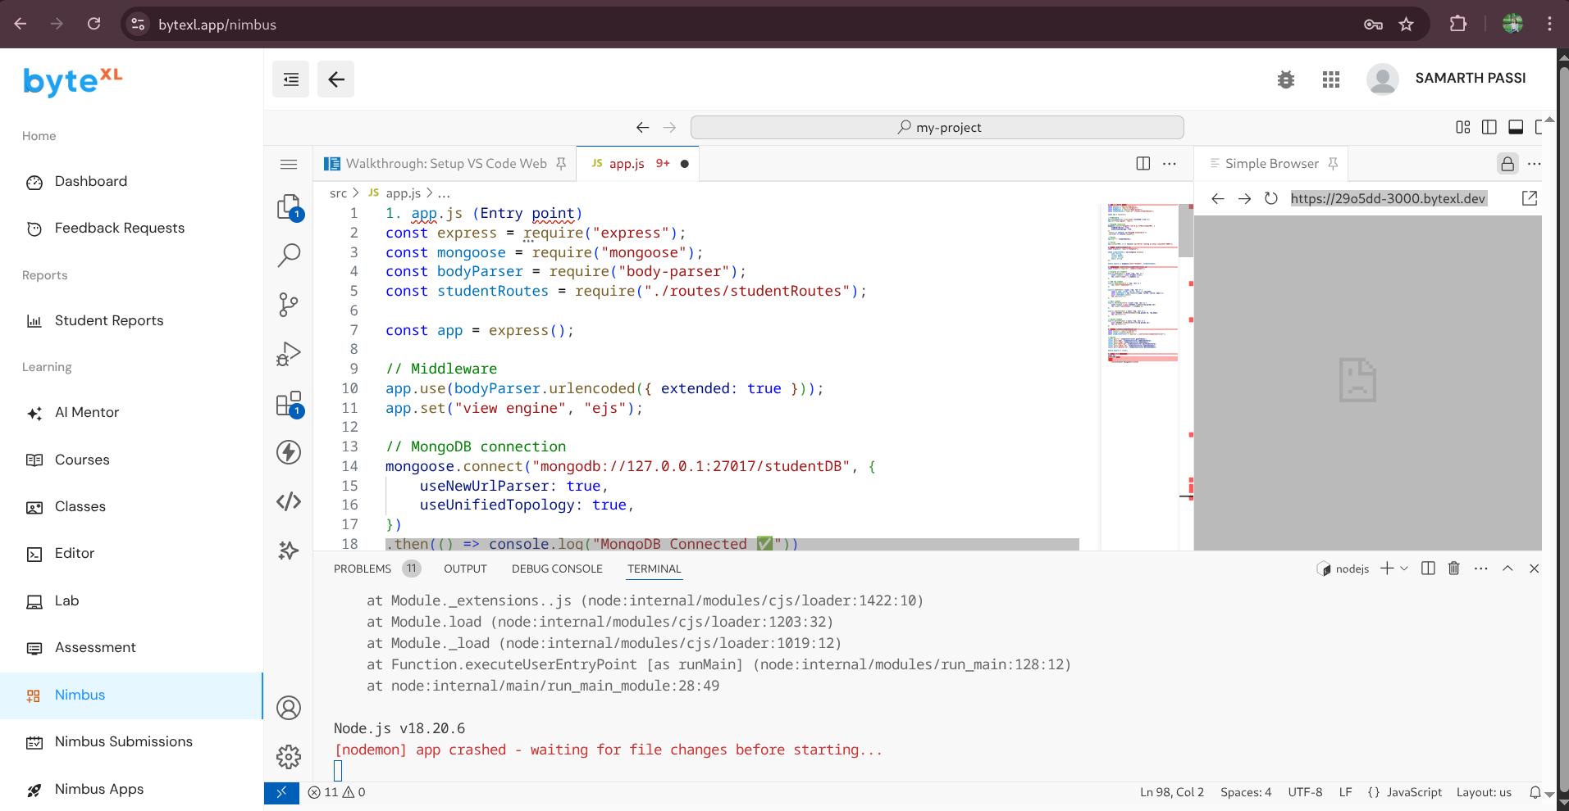

Learning Outcomes
- Understanding of MVC Architecture
  - Separation of concerns improves code organization and scalability.
- Practical use of MongoDB
  - Handling NoSQL database with schemas, queries, and CRUD operations.
- Integration of Express.js with MongoDB
  - Learn to create routes, controllers, and views.
- Full-Stack Development Skills
  - Backend (Node.js + MongoDB) + Frontend (EJS templates).
- Problem-Solving Skills
  - Designing a real-world system that manages and manipulates student data.

